Title: Times New Roman; Size-16; Line Spacing Exactly 20; Paragraph Spacing: After Paragraph-24 pt.**
First Author Name ¹*, Second Author Name², Third Author Name³
¹Affiliation, Address, Postcode, City, Country
²Affiliation, Address, Postcode, City, Country
³Affiliation, Address, Postcode, City, Country

ABSTRACT

This paper templet is copyright by Global Conference on Engineering and Technology organized by Global Academy of Training & Research (GATR). The first page of the manuscript should include the title of the manuscript and complete contact information for each author with author name, affiliation, full postal mail address, and email address. As noted, the corresponding author should be clearly noted in the case of multiple authors, and should be marked by *. In typing the abstract follow the aforementioned format without altering. Your abstract should not exceed from 200 words. The font size must be 11. Line spacing must be exactly 12 pt.

Type of Paper: Conceptual / Empirical/other

Keywords: Type keywords, separated by semicolons; a minimum of five keywords and maximum not more than ten.

__________________________________________________________________________________
- Introduction
Preamble of the paper with the 12 font size and follow same for other sections. The paragraphs continue from here and are only separated by numbered headings, subheadings, images and formulae. The section headings are arranged by numbers, bold, font size is 12, line spacing must be exactly 12 pt. Spacing for headers must be 12pt., before and after.
General Rules: Margin must be Normal.

Here follows the further instructions for authors.
2. Heading-level 1
Title of heading must be in Times New Roman, font size 12, Bold, Line spacing must be exactly 12 pt. Spacing must be 12 pt. before and after.
Type the paragraphs of the paper heading. Text must be in Times New Roman, font size must be 12. Line spacing must be exactly 12 pt.
2.1 Heading-level 1
Title of sub-heading must be in Times New Roman, font size 12, Italic, Line spacing must be exactly 12 pt. Spacing must be 12 pt. before and after.
Type your sub-heading paragraphs here. Text must be in Times New Roman, font size must be 12. Line spacing must be exactly 12 pt.
2.1.1 Heading-level 1
Title of sub-heading must be in Times New Roman, font size 12, Line spacing must be exactly 12 pt. Spacing must be 12 pt. before and after.
Type your sub-heading paragraphs here. Text must be in Times New Roman, font size must be 12. Line spacing must be exactly 12 pt.
Bulleted lists must look like this:
- First point
- Second point
- And so on
Please do not alter the formatting and style layouts which have been set up in this template document. Do not number pages on the front, as page numbers will be added separately for the preprints. Leave a line clear between paragraphs.
3. Heading-level 2
Type your paragraphs here. For all formatting structure refer to previous guidelines
3.1 Tables
All tables should be numbered with Arabic numerals. Every table should have a caption. Headings should be placed above tables, font size 11, left justified. Tables must be embedded into the text and not supplied separately. Table format: font size must be 11, line spacing must be exactly 11 pt. Spacing must be 0 pt. Before; 6 pt. After and it must centered
Table 1. An example of a table.
An example of a column heading | Column A (t) | Column B (t)
And an entry | 1 | 2
And another entry | 3 | 4
And another entry | 5 | 6
3.2 Illustrations
Illustrations must be numbered with Arabic numerals (e.g. Figure 1; Figure 2 ;…). The name of the figure must be written BELOW the figure. The font size must be 11, Spacing of figure name must be 6pt. before and 12pt. after, center justified.
Figures must be high quality which is a 300 DPI resolution to produce a high quality output. Authors are suggested to avoid any illustration which is unclear, diminishing and has fuzziness and low readability. The table and figure must not be distorted, out of margin and numbers can be seen clearly in the illustrations.

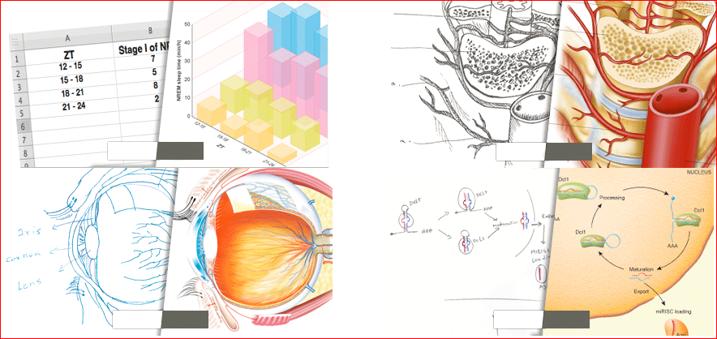
Figure 1. Name of the figure

3.3 Equations
Equations and formulae should be typed in Mathtype, and numbered consecutively with Arabic numerals in parentheses on the right hand side of the page (if referred to explicitly in the text). They should also be separated from the surrounding text by one space.
(1)

Acknowledgements
Type your acknowledgements here. Acknowledgements and Reference headings should be bold and left justified. First letter capitalized, but have no numbers. The font size 12.
References
In the text the number of the reference should be given in square brackets. For references with more than two authors, text citations should be shortened to the first name followed by et al., e.g. Jones [1] discovered that...; recent results from Brown and Carter [2] and Green et al. [3] indicate that (…).
Only essential references, which are directly referred to in the text, should be included in the reference list.
References must be listed in numerical order at the end of the paper. Do not begin them on a new page unless this is absolutely necessary. They should be prepared according to the sequential numeric system making sure that all material mentioned is generally available to the reader.
of remaining authors; article title (where provided); abbreviated journal title (in italics), year of publication, volume number and page numbers.

References to books should include: author's surname and initials; surnames and initials of remaining authors; the book title (in italics); the place of publication and the name of the publisher; and year of publication. References to multi-author works should include author's surname(s) and initials, the chapter title (where provided); "In:" followed by book title (in italics); initials and name(s) of editors(s) in brackets; volume number and pages; the place of publication and name of the publisher, followed by the year of publication.

Here is an example of some references listed according to the sequential numeric system:
[1] Van der Geer J, Hanraads JAJ, Lupton RA. The art of writing a scientific article. J SciCommun 2000; 163:51–9.
[2] Strunk Jr W, White EB. The elements of style. 3rd ed. New York: Macmillan; 1979.
[3] Mettam GR, Adams LB. How to prepare an electronic version of your article. In: Jones BS, Smith RZ, editors. Introduction to the electronic age, New York: E-Publishing Inc; 1999, p. 281–304.

Footnotes
Footnotes should be avoided if possible. Necessary footnotes should be denoted in the text by consecutive superscript letters. The footnotes should be typed single spaced, and in smaller type size (8pt), at the foot of the page in which they are mentioned, and separated from the main text by a short line extending at the foot of the column. The .Els-footnote. Style is available in the "MS Word Template" for the text of the footnote.
Please do not change the margins of the template as this can result in the footnote falling outside printing range.

- An example appendix
Authors including an appendix section should do after the References section. Multiple appendices should all have headings in the style used above. They will automatically be ordered A, B, C etc.

* Paper Info: Revised: Month, Year Accepted: Month, Year
* Corresponding author: E-mail: someone@text.com Affiliation: Faculty, University

